Task 1:

I_ref = 204.5 uA

Current through pin 14 resistor: 233.71 uA

Pin 10 resistor: 461.7 uA

Sources of error: nonideal mosfets

Imperfect resistors

Resistance of wires

Iref is not perfectly 200uA

task 2. 2

Incorrect vin:

Ch1: wave in : 100mVpp

Ch2: output : 3.4 Vpp

Gain: vout/vin =

Correct Vin:

Task 3

Estimate gain of CSA in task 6.5.1 (task 1)

Estimate open loop gain from 6.5.2 (task 2)

Screenshots next few pages (2v, 1v, .5v, -1v, -2v)

Has DC and sin wave because I did sin first then realized it wanted a DC input. You can just ignore the sin wave unless its actually useful 😊

Screenshots:

2v:

1v:

5mV:

-1v:

-2v:

[end of task 3 screenshots]

Task 3.8

Input = 2sin(2pi100t) instead of DC

Task 4.3

Common drain amplifier added

Square : output (this would be a sin wave too but the gain is so high it clips)

Sin: input (as usual)

Task 5.1

Too high and it clips it. This is wavegen at 200mV

Reasonable since we want to limit to 2V output and .2V input is good for our -10 gain

Expected gain: -10

Vin = 404.11 mVpp = .40411 Vpp

Vout = 3.8836 Vpp

Gain = 3.8836 / .40411 = 9.61287 (but negative)

Percent error: 3.8713%

Again agian 3

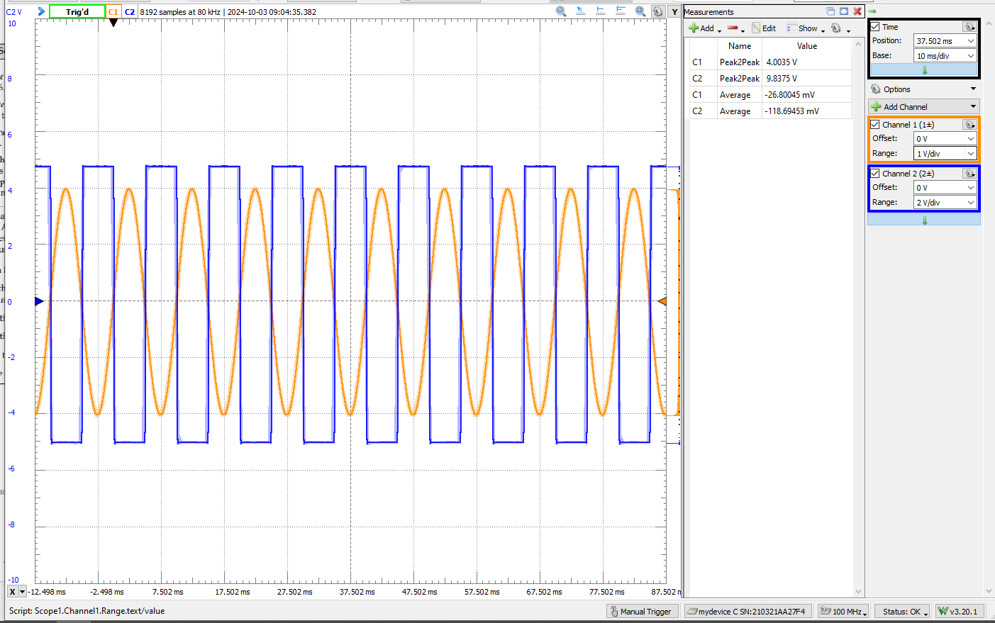

4

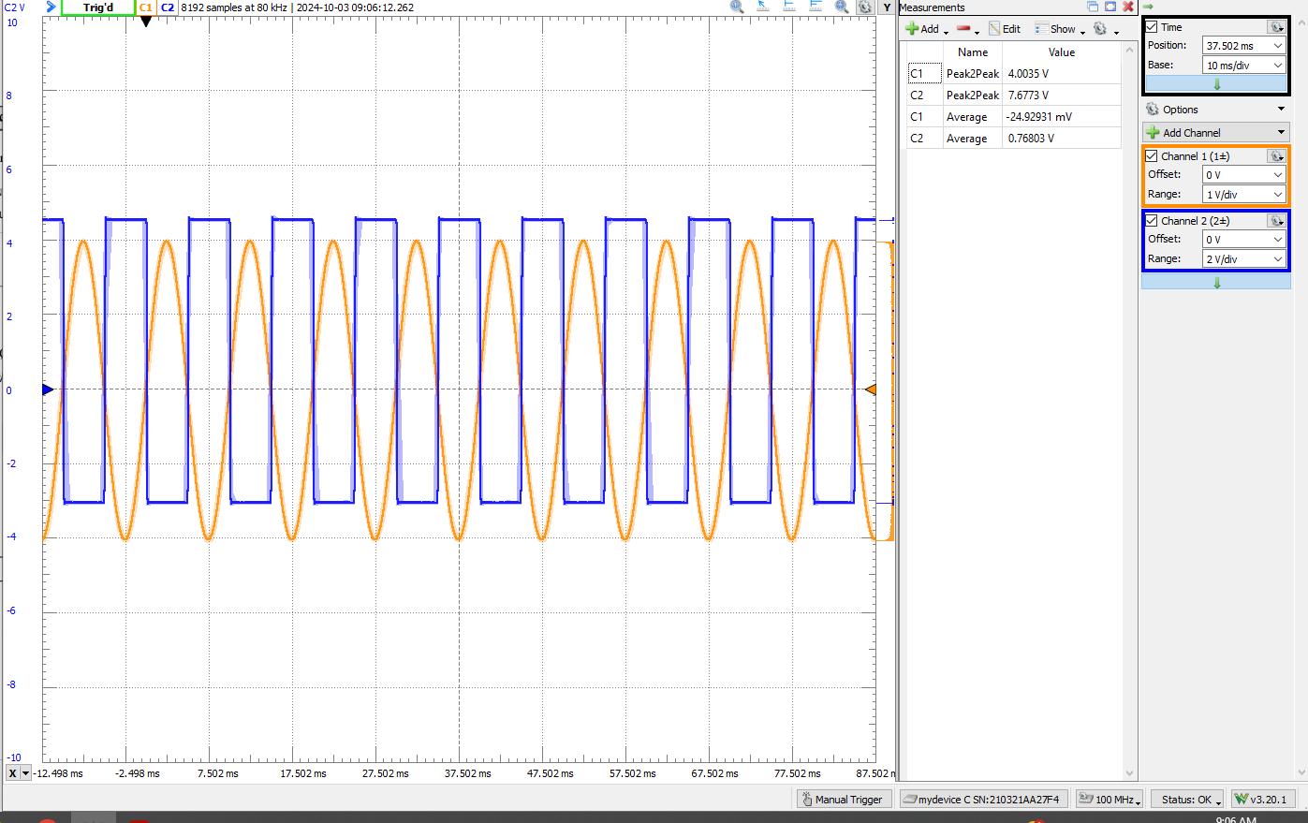

5

